**CREATING A BRAND NAME, BRAND EMAIL AND BRAND LOGO USING CANVA**

1. **INTRODUCTION**

**1.1 *Brand Name*:** Hungry Hub

* 1. ***Category*:** Restaurant
  2. ***Brand Email*:** [hungryhubrestaurants@gmail.com](mailto:hungryhubrestaurants@gmail.com)
  3. ***Overview***

In this project, is going to be creating Brand Name, Brand Email and Brand Logo using

Canva. After publish it is going to be uploaded in Github.

* 1. ***Purpose***

The purpose of the project is learnt how to create a Brand Name, Brand Email and Brand Logo using Canva for digital marketing. Because Canva is a easy platform to create a logo and edit it.

1. **PROBLEM DEFINITION AND DESIGN THINKING**
   1. ***Empathy map***

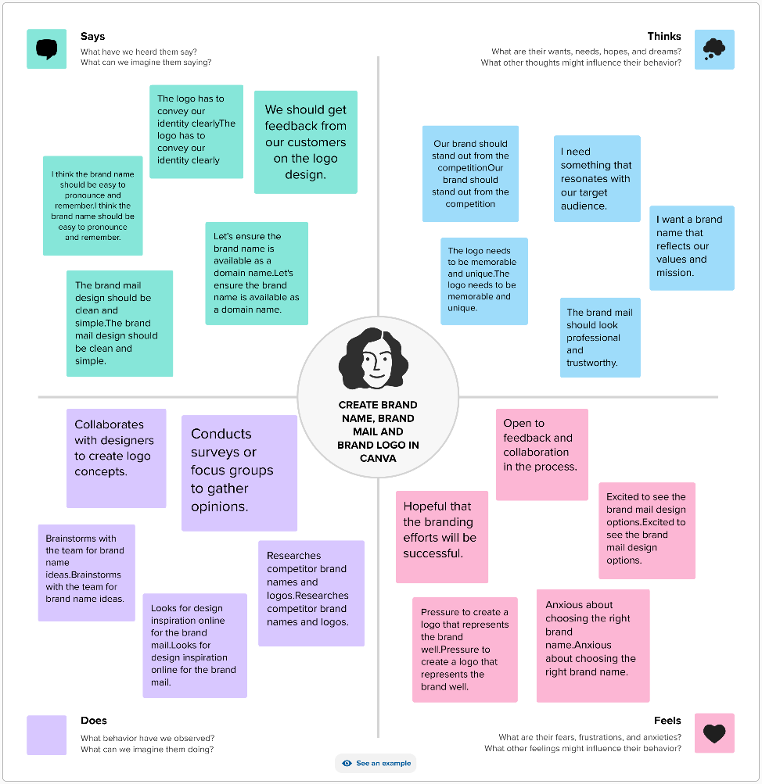

* 1. ***Ideation & Brainstormimg***

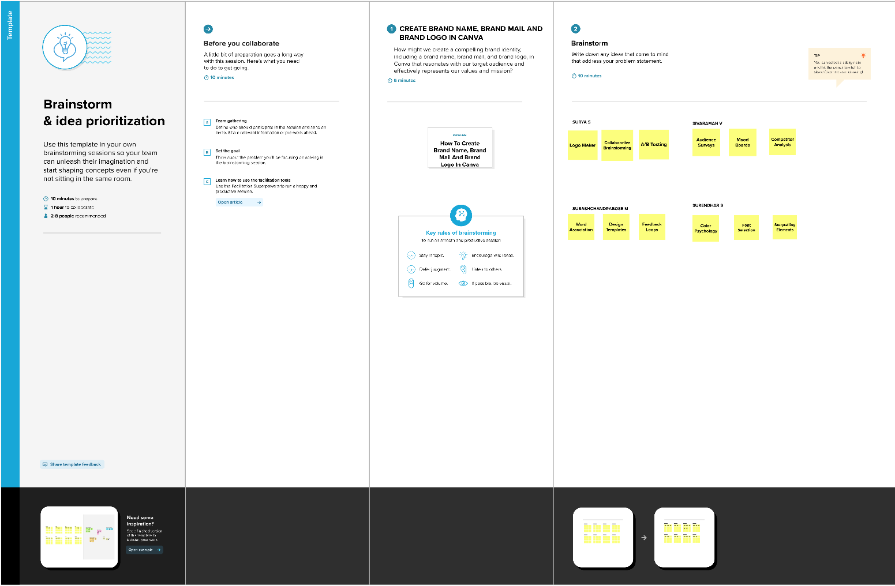

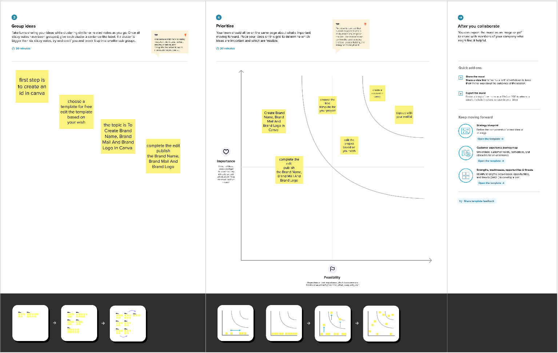

1. **RESULT**

***LOGO*:**



1. **ADVANTAGES**
2. Canva is budget-friendly.
3. Canva offers a professional look.
4. Canva is a customize template.
5. Canva is collaboration design projects.

**DISADVANTAGES**

1. Alignment concerns
2. Unique elements cannot be created.
3. Internet connection required.
4. Subscription cost.
5. **APPLICATION**

For digital marketing this brand name, brand email and brand logo will be more useful to promote their service and sale the products, etc.

1. **CONCLUSION**

In this we learnt to how to use Canva tool to create brand name, brand email and brand logo and use it for effective business purposes.